
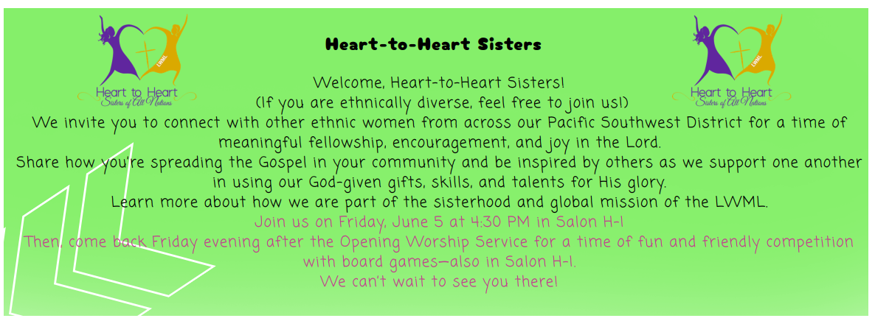
Register for the convention at
www.psdlwml.org
A limited number of scholarships are available? The convention registration form, and the scholarship application (if needed) are available at www.psdlwml.org at the link “General Scholarship Form”
Questions? Maria Espinoza (cuatro-esp@msn.com)
or Diani Voss (dianivoss@gamil.com)

